In this activity, you will use NiFi to perform a data load into a MySQL database. You will be using real earthquake data from [USGS](https://earthquake.usgs.gov/earthquakes/search/)

[Links to an external site.](https://earthquake.usgs.gov/earthquakes/search/)

and storing it within your database. This activity uses content from Videos 17.4, 17.5, 17.6, and 17.7, and you will need to follow along with the videos to create two *containers* before beginning this activity.

Before you begin the steps of the activity below, please be sure you have your two *containers* running within Docker and that they are connected to the same network; one *container* is for the NiFi *server* and one is for MySQL.

Before beginning this activity, review the submission instructions below to ensure that you collect the required screenshots as you progress through the activity.

Note that this activity has been tested using a Windows OS and the Catalina version of a Mac OS. If you use the Big Sur OS, you are recommended to use the myPhpAdmin *container* as demonstrated in this article: [Run MySQL & phpMyAdmin Locally Using Docker](https://migueldoctor.medium.com/run-mysql-phpmyadmin-locally-in-3-steps-using-docker-74eb735fa1fc)

[Links to an external site.](https://migueldoctor.medium.com/run-mysql-phpmyadmin-locally-in-3-steps-using-docker-74eb735fa1fc)

[Links to an external site.](https://migueldoctor.medium.com/run-mysql-phpmyadmin-locally-in-3-steps-using-docker-74eb735fa1fc)

.

**References**

[USGS. “Search Earthquake Catalog.” *USGS: Science for a Changing World*. Accessed December 14, 2021.](https://earthquake.usgs.gov/earthquakes/search/)

[Links to an external site.](https://earthquake.usgs.gov/earthquakes/search/)

[https://earthquake.usgs.gov/earthquakes/search/.](https://earthquake.usgs.gov/earthquakes/search/)

[Links to an external site.](https://earthquake.usgs.gov/earthquakes/search/)

[Yuste, Miguel. “Run MySQL & PhpMyAdmin Locally in 3 Steps Using Docker.” *Medium*. 2019. https://migueldoctor.medium.com/run-mysql-phpmyadmin-locally-in-3-steps-using-docker-74eb735fa1fc.](https://migueldoctor.medium.com/run-mysql-phpmyadmin-locally-in-3-steps-using-docker-74eb735fa1fc)

[Links to an external site.](https://migueldoctor.medium.com/run-mysql-phpmyadmin-locally-in-3-steps-using-docker-74eb735fa1fc)

**To complete this activity, follow these steps:**

1. First, you will configure your database in MySQL Workbench. You are going to generate a new database called usgsand, within that database, you will add a table called earthquakes. Run the following *query* to generate the database:

| CREATE DATABASE IF NOT EXISTS usgs;  USE usgs; |
| --- |

1. Next, generate the earthquakes table with these 23 column fields:

| create TABLE earthquakes(  idx int,  time varchar(100),  latitude varchar(100),  longitude varchar(100),  depth varchar(100),  mag varchar(100),  magType varchar(100),  nst varchar(100),  gap varchar(100),  dmin varchar(100),  rms varchar(100),  net varchar(100),  id varchar(100),  updated varchar(100),  place varchar(100),  type varchar(100),  horizontalError varchar(100),  depthError varchar(100),  magError varchar(100),  magNst varchar(100),  status varchar(100),  locationSource varchar(100),  magSource varchar(100) ); |
| --- |

1. Confirm that you have an empty table. Perform the following *function*:
2. SELECT * FROM earthquakes
3. Provide a screenshot of your MySQL Workbench to show that you have successfully initialized an empty earthquakes table in the usgs database.
4. Download the [Activity17-2.csv](https://classroom.emeritus.org/courses/10605/files/3007163/download) CSV file and place it on your NiFi *server* in a newly created *directory* with the path /opt/nifi/current-nifi/data.  
   To do this, open the NiFi CLI in the Terminal through your Docker window and navigate to the following path: opt/nifi/*.*Create a *directory* called current-nifi and create a data *subdirectory* within it. Open up a second Terminal window on your local machine and navigate to the folder where you downloaded the Activity17-2.csv CSV file. Perform the following command:  
   docker cp ./Activity17-2.csv nifi:/opt/nifi/current-nifi/data  
   Navigate back to the NiFi CLI window. Provide a screenshot to show that the Activity17-2.csv CSV file is now on the NiFi *server*.
5. Open NiFi in your browser. You should already have a *controller* service called MySQL. The MySQL service will be set up exactly the same as in [Video 17.7](https://classroom.emeritus.org/courses/10605/pages/creating-an-etl-pipeline-19-10). The *driver* must also be configured, as demonstrated in [Video 17.6](https://classroom.emeritus.org/courses/10605/pages/creating-an-etl-pipeline-19-10). Next, you are going to add two more *controller* services: a *reader* and a *writer*. The *reader* is going to read the data from your FlowFiles, and the *writer* will write the data to MySQL commands.

a.To create a *reader*, go to the *controller* services, select the “+” option and search for “CSVReader”. Open up the configurations and confirm that your screen looks like the following: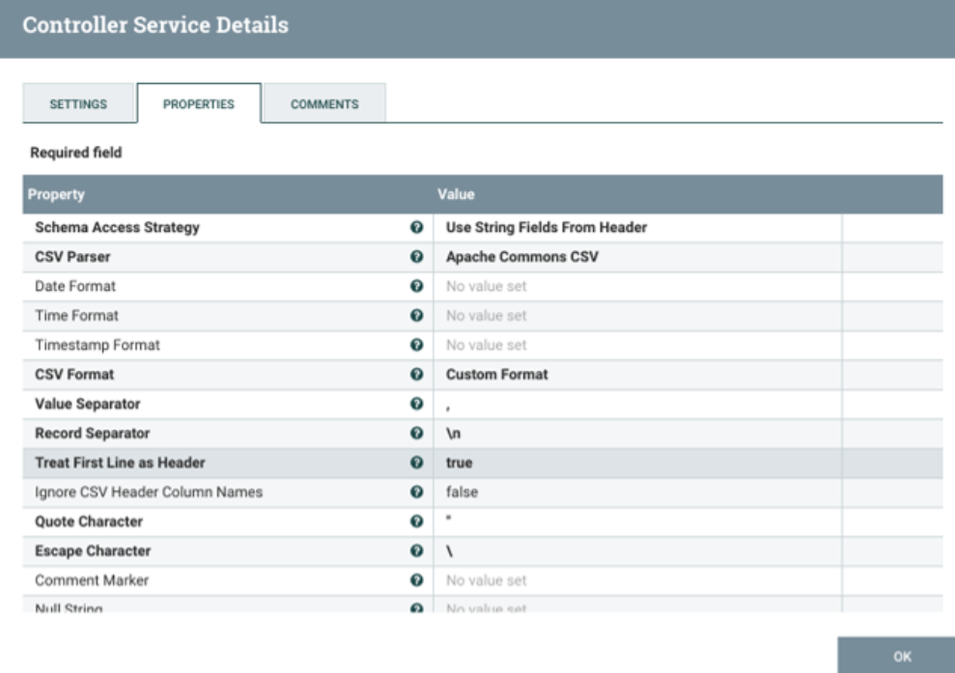

b. To create a *writer*, select the “+” option again and search for “JsonRecordSetWriter”. Open up the configurations and confirm that your screen looks like the following: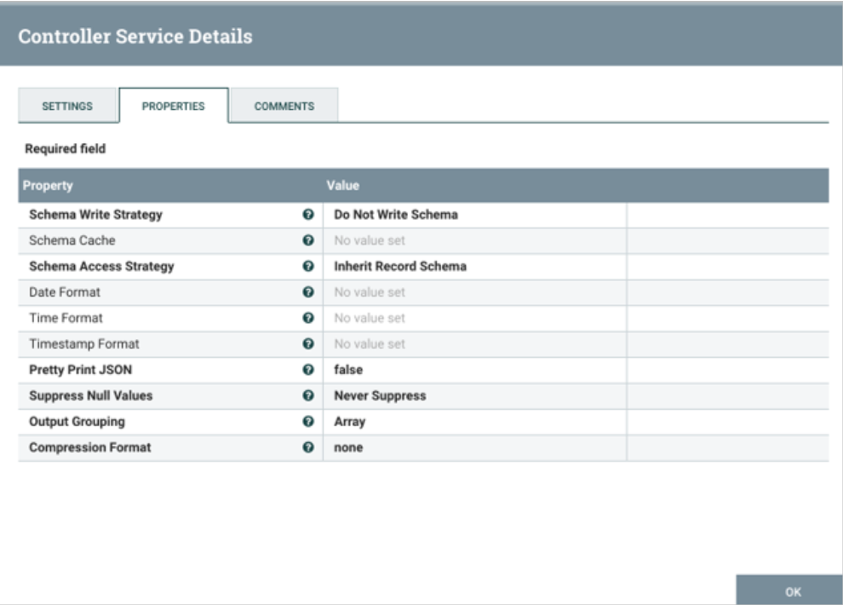

Select the lightning bolt symbol to start up each *controller* and select “Service Only” under the service and reference components menu.  
Provide a screenshot of the *controller* screen to show that the three *controller* services (*reader*, *writer*, and MySQL) are enabled.

4. Now it is time to set up the data pipeline. This will consist of five *processors* flowing in the order specified below:

1. GetFile *processor.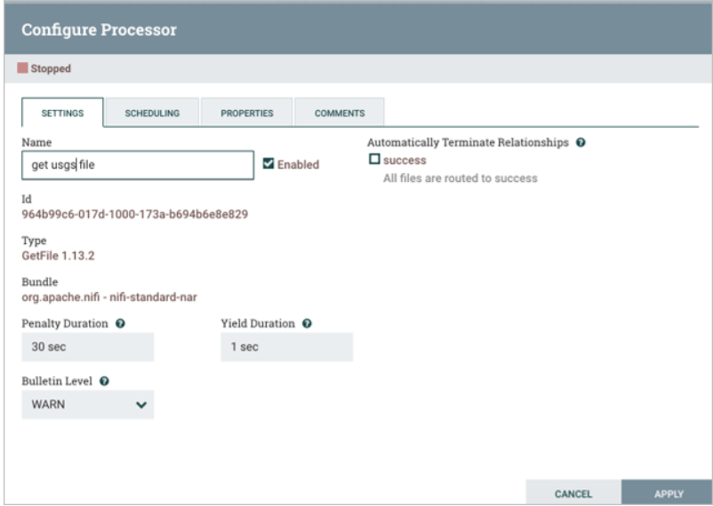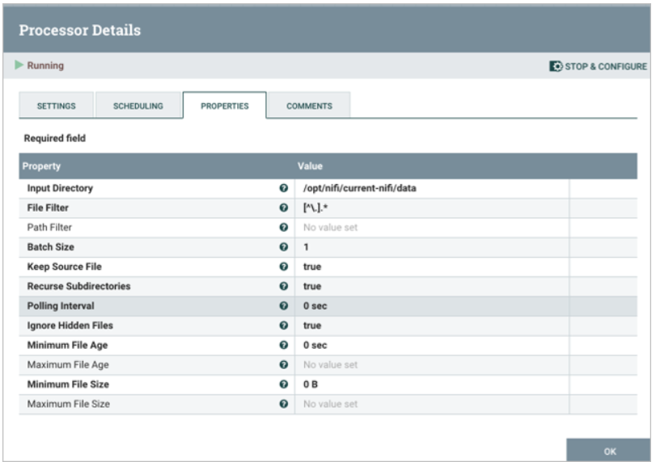*
2. SplitText *processor*:

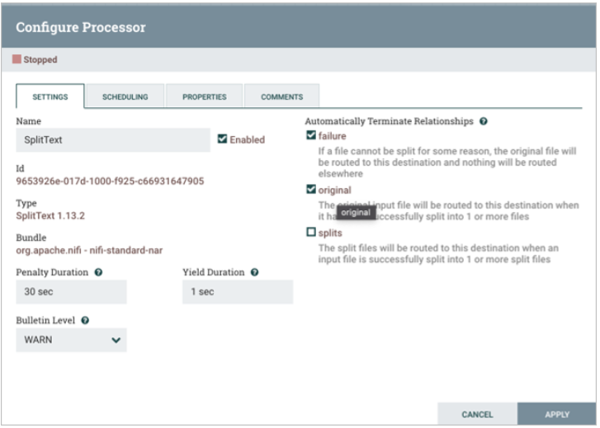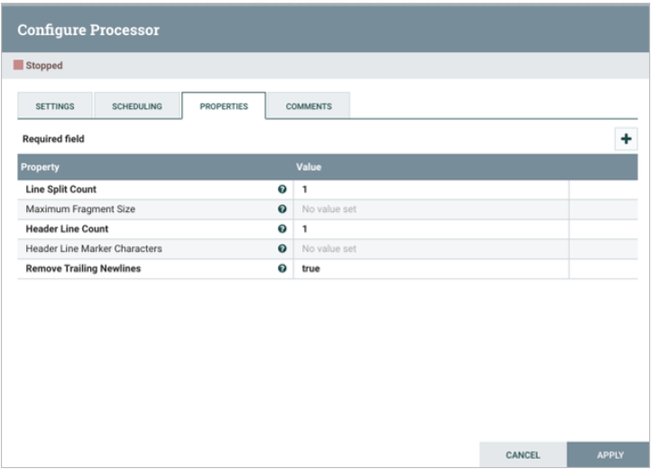

1. ConvertRecord *processor*:

Note that this is where you will use the *reader* and *writer* *controllers* that you configured in Step 3.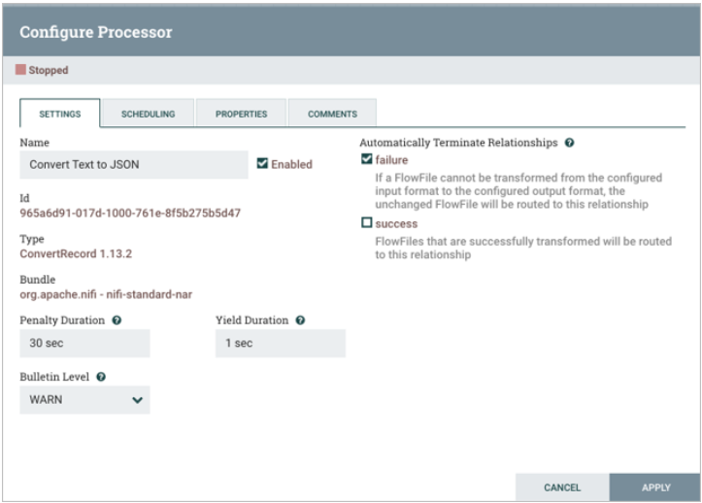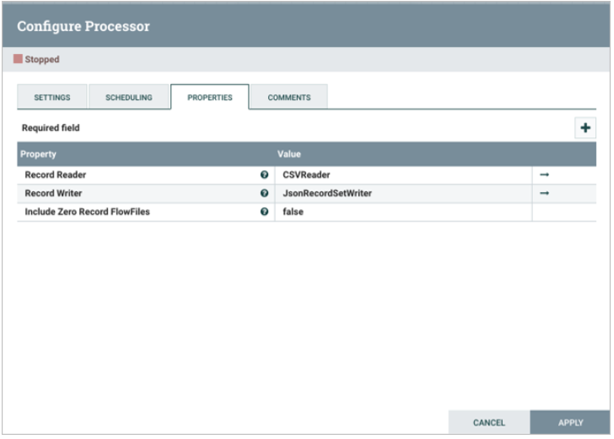

1. ConvertJSONToSQL *processor*: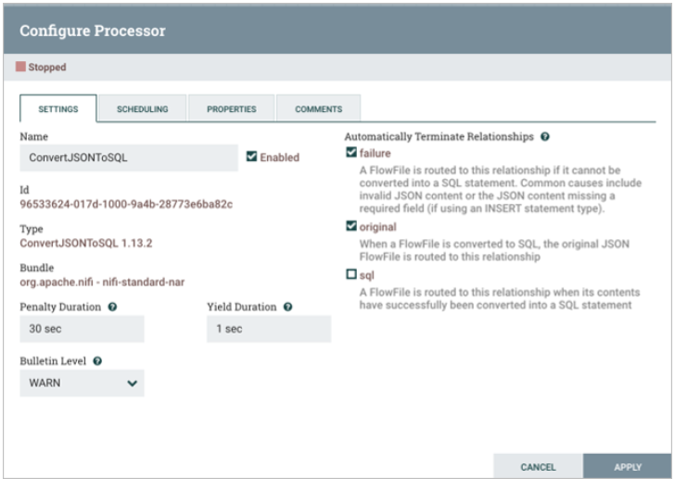

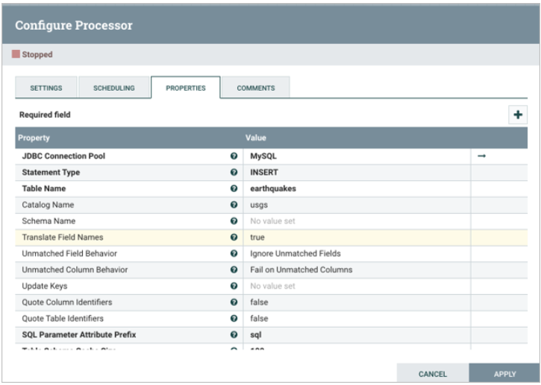

1. PutSQL *processor*:

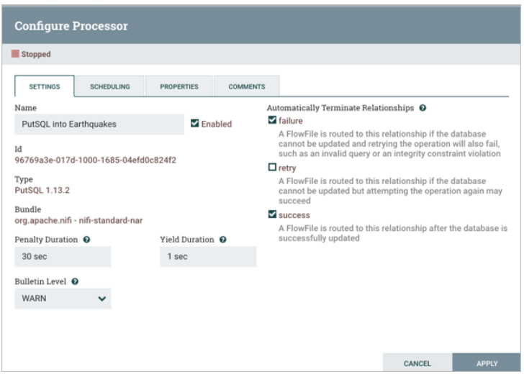

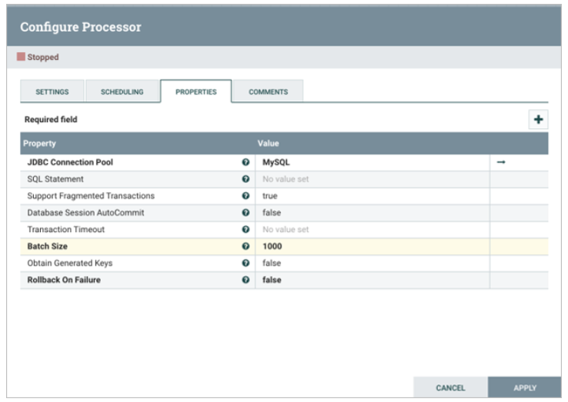

Provide a screenshot of your complete data pipeline, including all five *processors*: GetFile, SplitText, ConvertRecord, ConvertJSONToSQL, and PutSQL.

5. Now that you have all five *processors* configured, you must make connections. There will be a total of five *connectors*. The first four *connectors* will connect the five *processors*, and the last *connector* will be a *loop* *connector* over the last *processor*, PutSQL, to handle retries. Retries are necessary because databases have settings to ensure that data is not being read and written at the same time. If the data table is locked when trying to perform a load, the *processor* must retry once the lock is removed.

1. The *connector* between the GetFile and SplitText *processors* will be a success relationship:

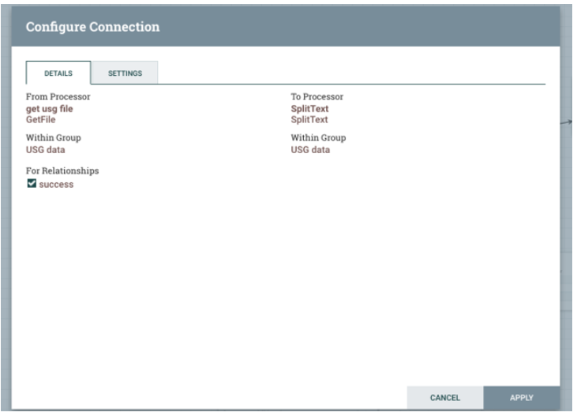

1. The *connector* between the SplitText and ConvertRecord *processors* will be a splits relationship:

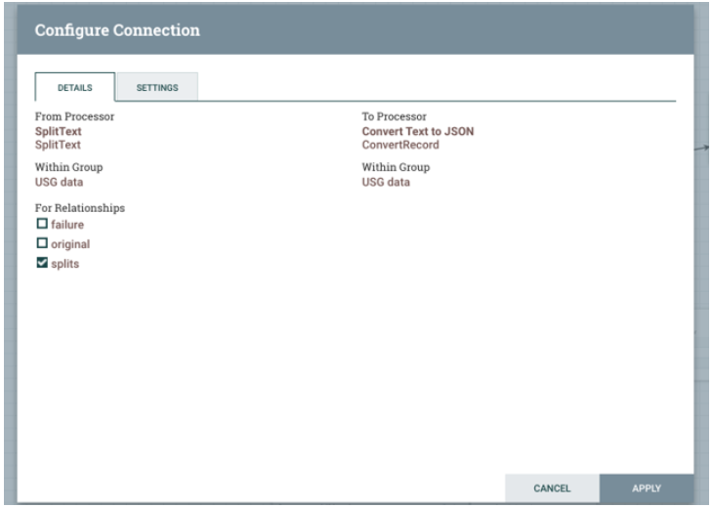

1. The *connector* between the ConvertRecord and ConvertJSONToSQL *processors* will be a success relationship:

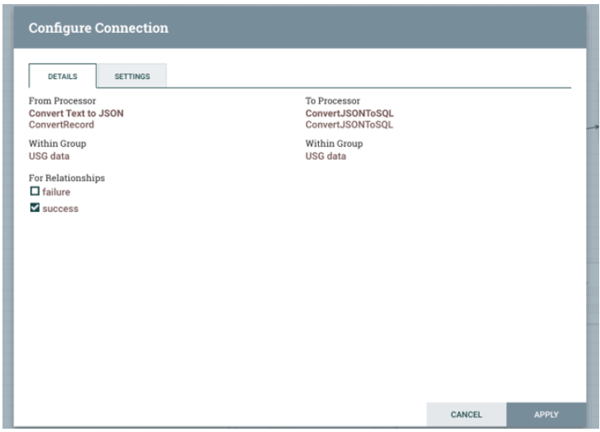

1. The *connector* between the ConvertJSONToSQL and PutSQL *processors* will be an sql relationship:

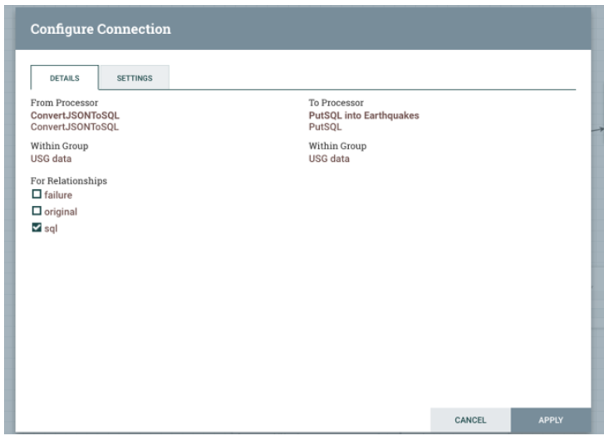

1. The final *connector* will stem from the PutSQL *processor* and *loop* back to itself. This will be a retry relationship:

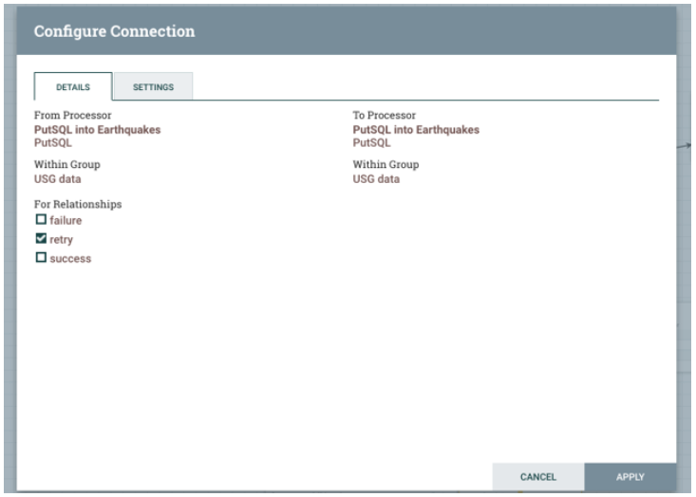

Provide a screenshot of all five *processors* to show that the correct connections have been made.

6. Next, try starting each *processor*, beginning with the GetFile *processor*. Watch the data propagate down toward the PutSQL *processor*. Provide a screenshot of your NiFi browser screen to show all five *processors* connected and running.

7. Navigate back to your MySQL Workbench and perform the following *query*:  
SELECT * FROM earthquakes;  
There should now be rows of data that you just loaded into the table. Provide a screenshot of the result of this *query* to show that the earthquakes table in the usgs database is now saturated with data.

**Submission Instructions:**

Your submission for this activity should be a Word document that includes the following screenshots, each labeled for the step that the screenshot represents:

1. Provide a screenshot of your MySQL Workbench to show that you have successfully initialized an empty earthquakes table in the usgs database.
2. Provide a screenshot to show that the Activity17-2.csv CSV file is now on the NiFi *server*.
3. Provide a screenshot of the *controller* screen to show that the three *controller* services (*reader*, *writer*, and MySQL) are enabled.
4. Provide a screenshot of your complete data pipeline, including all five *processors*: GetFile, SplitText, ConvertRecord, ConvertJSONToSQL, and PutSQL.
5. Provide a screenshot of all five *processors* to show that the correct connections have been made.
6. Provide a screenshot of your NiFi browser screen to show all five *processors* connected and running.
7. Provide a screenshot of the result of this *query* to show that the earthquakes table in the usgs database is now saturated with data.